**Score Card Print Setup Steps**

* Select good colour printer for good outputs

1. **Double click** on score card image(**jpg**)

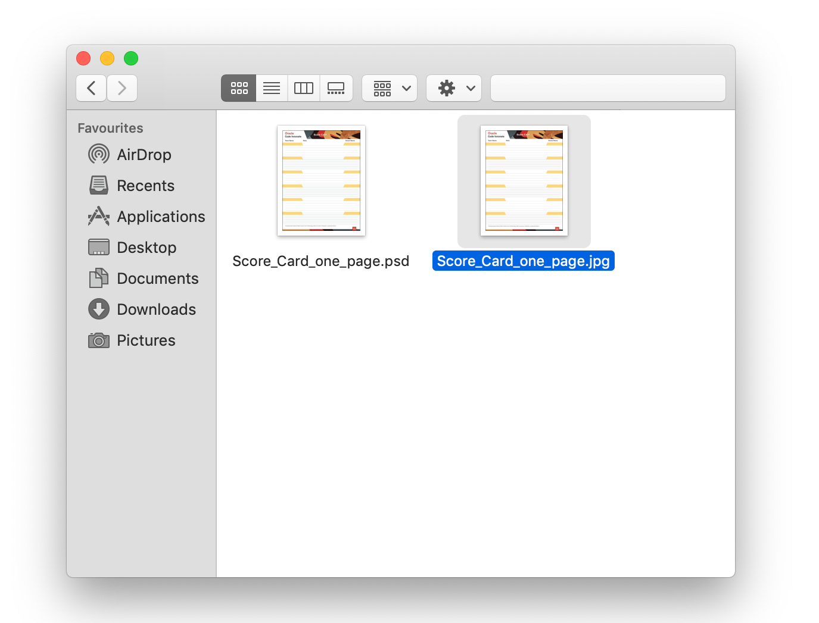

1. After image popups, go to **file** (top navigation), **click print** option

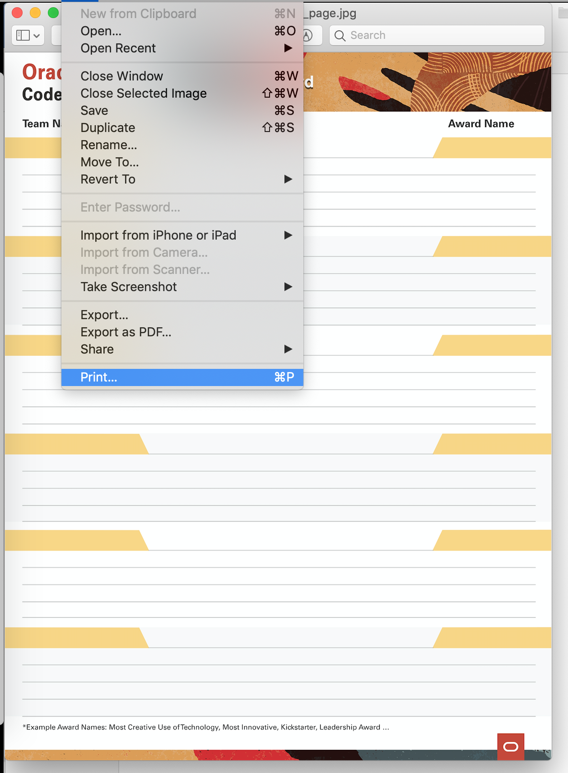

1. Enter Number of **Copies** and click **Print**

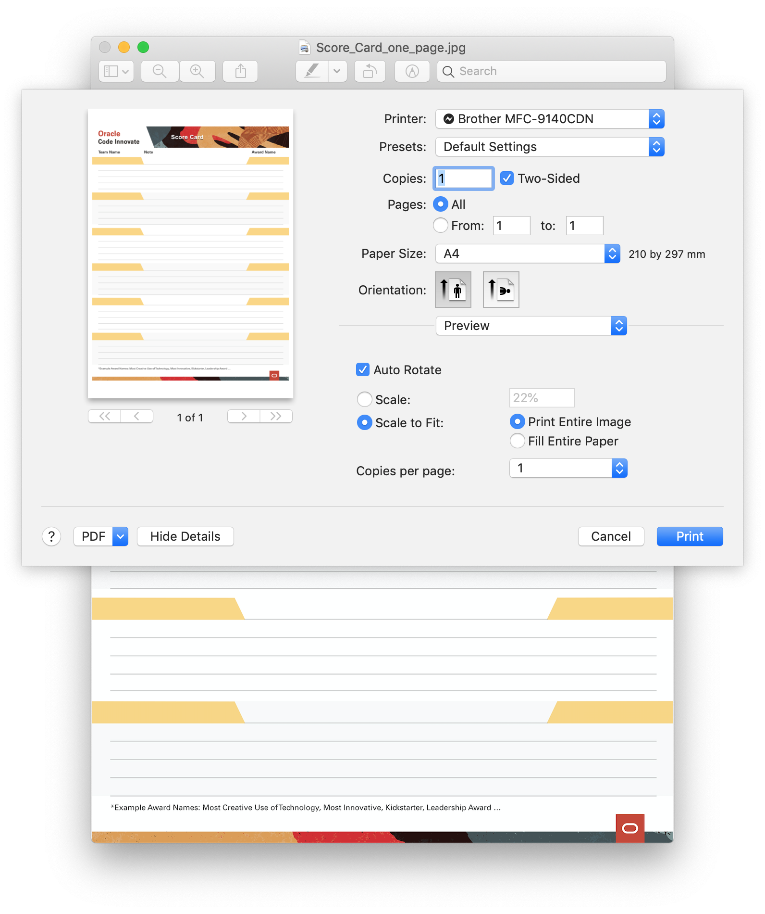

1. Final Printout

